ENVIRONMENTAL PHYSICS
Half Unit - Two hours.
The paper consists of two sections: A & B.

Section A contains one question, comprising of 6 parts. (30 marks total)

Section B contains three questions on selected parts of the course. (15 marks each).

Candidates are required to:
Answer ALL parts of Section A and TWO questions from Section B

Section A.

A1. Does the greenhouse effect apply to a greenhouse? Briefly explain your answer.
[5 marks]

A2. Describe the largest negative and the largest positive feedback operating in the climate system in response to an increase of atmospheric CO2 concentration?
[5 marks]

A3. The power conversion efficiency η of an ideal solar thermal converter is given by the expression:

$$η=\left\{1−{\left(\frac{T_{c}}{T_{\text{sun}}}\right)}^{4}\right\}\left(1−\frac{T_{p}}{T_{c}}\right)$$

where T_{sun} and T_{p} are the radiation temperatures of the sun and the ambient, respectively, and T_{c} is the temperature of the converter. Briefly explain the origin of the two factors in the equation. Give two reasons why this efficiency would not be achieved in practice.

[4 marks]

A4. Calculate the solar power conversion efficiency of a tree in a temperate forest where the mean solar irradiation is 150 W m⁻², given the following information:

Yield of dry wood: 7,000 kg hectare⁻¹ year⁻¹
Energy density of dry wood: 18 MJ kg⁻¹

Making a reasonable estimate for the non-food energy requirements of a human in a developed country, calculate the area of forest that is required to provide the energy consumed by one person.

1 hectare = 10⁴ m².

[4 marks]

A5.
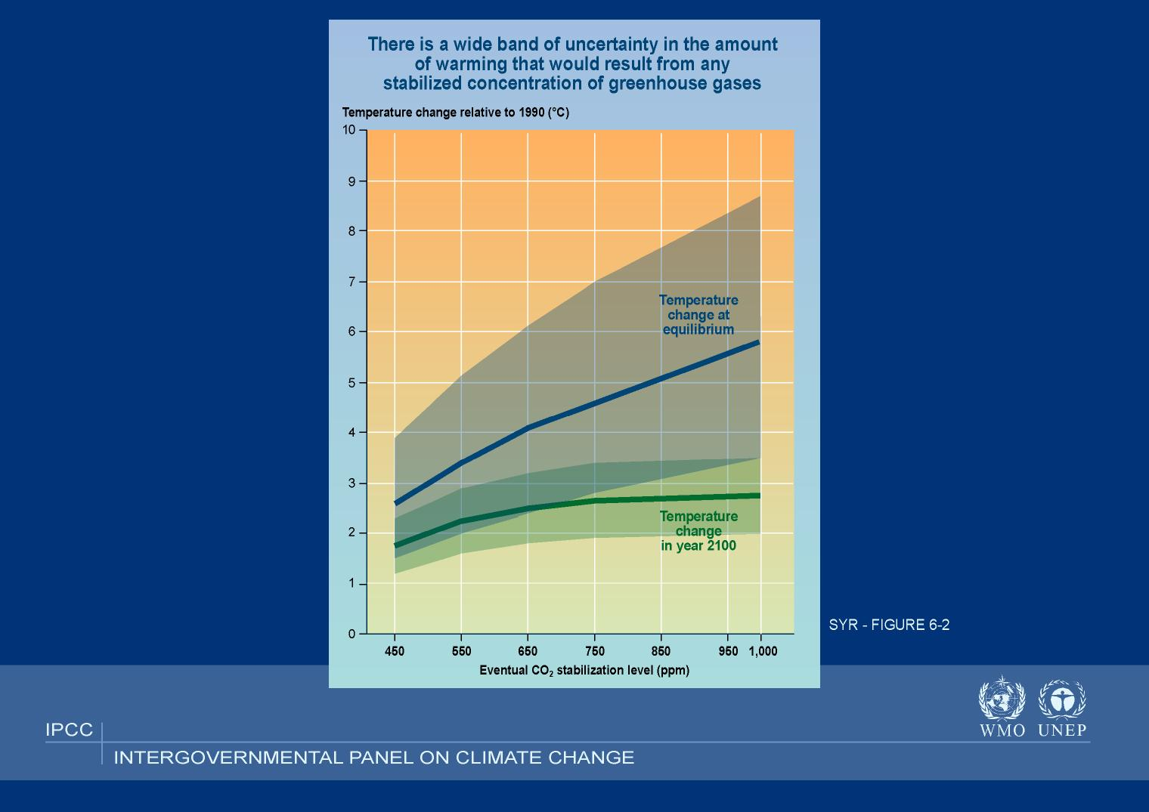
Fig. 1
Temperature change at equilibrium
Temperature change in year 2100

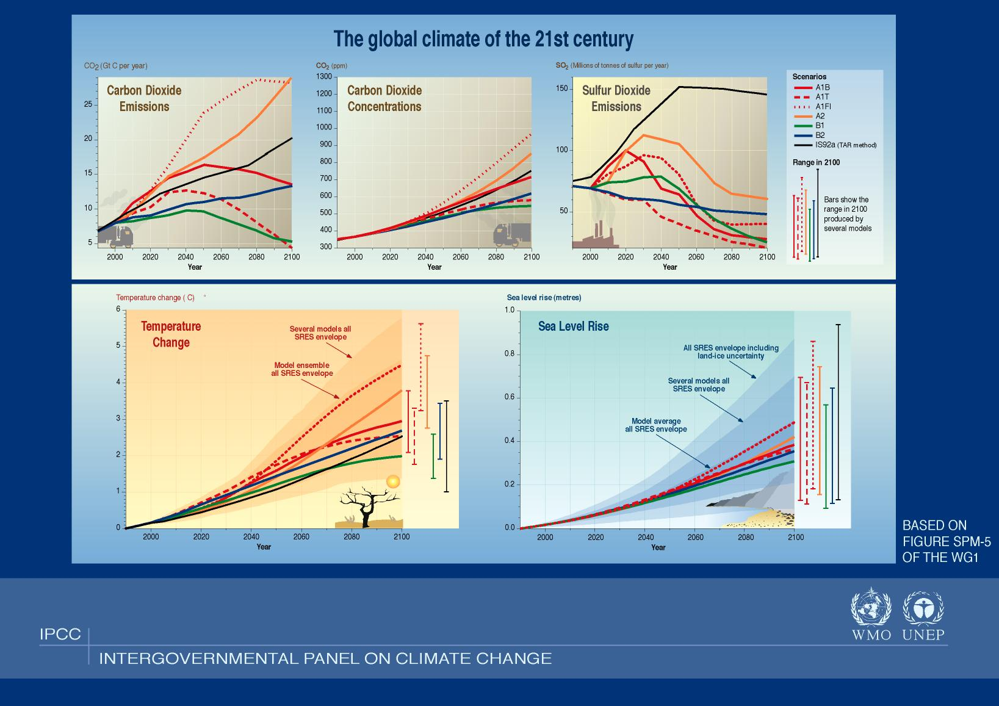
Fig. 2

Fig. 2

Using bullet points, interpret the main features of the two graphs shown above.
There is no need to discuss details of the various models shown. Concentrate on the trends in the underlying processes.
[6 marks]

A6.

(a) The absorption of radiation is expressed by the Beer-Lambert law:

I(λ) = I₀(l) exp (-x ρ Κ(λ))

where I₀(λ) denotes the initial intensity of a light source
I(λ) is the intensity of the radiation after it has passed through a layer of thickness x, where the species to be measured is present at the density ρ;
Κ(λ) denotes the specific absorption coefficient at the wavelength λ which can be measured in the laboratory.

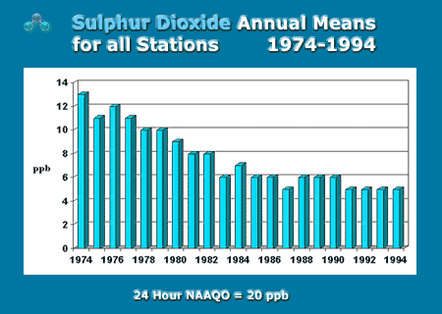
Explain (in short notes – not an essay!) how a concentration of gas can be measured. What are the main sources of error in using this approach?

(b) According to Environment Canada, SO₂ concentration over the last 30 years has followed the trend shown in the figure on the right. Explain the main features and why this trend occurred.

[6 marks]

Section B

B1.

Estimate the following quantities, using the data below and, where necessary, your best estimates of missing data.

- How many nuclear power stations would China need to build if its population were to enjoy the same per capita energy consumption as Canada and nuclear were chosen as the sole new power source?

- How many years of uranium remain if this were to happen?

- 1996 the total energy used in the world was about 400 million terajoules. How many nuclear reactors would be needed for that?

- Plot a graph of nuclear binding energy vs mass number A and annotate it showing where the energy comes from in fission reactions, and in fusion reactions.

DATA:

International energy consumption in 1998:
 | Population (millions) | kWh/ year/ capita
Canada | 30.30 | 16349
China | 1238.60 | 871

Additional data:
1 million barrel of crude oil per day (bbl/day) = 1MBPD = 80M tons coal per year = 0.2 ton UO₂ per year = 2.23 EJ/year.

According to official data, the world known recoverable uranium resources at 1/01/2003 are 3.537 million metric tonnes. Current consumption rate is about 68000 metric tonnes p.a.

A typical nuclear reactor generates about 1 GW electricity. Assume there is about 350GW nuclear
generation now.

[15 marks]

B2.

The Tropics (30°S-30°N) can be envisioned of consisting of warm and moist regions, co-existing with cold and dry regions. The associated surface temperature gradient drive large scale motions (the so-called Hadley/Walker cell) which export energy from the warm moist regions to the cold dry regions. We study here the relationship between this energy transport and the Tropics average surface temperature.

Our model is schematized in Fig. 1. The warm/moist regions are assumed optically thick and are represented by a single box (Box 1), where the physics of the “Blanket model” is assumed to operate. In the cold/dry regions (Box 2), we assume that the atmosphere is optically thin and that, as a result, the physics of the “Moon model” is operating. As mentioned above, the two boxes exchange energy, the flow of energy per unit time from Box 1 to Box 2 being denoted by $H$ (in W). The net amount of solar radiation received by the Tropics (Box1+Box2) is denoted by $S=(1−α)S_{o}R^{2}(π/3+{\sqrt{3}}/2)$ , expressed in W (see notations below). The surface area occupied by Box 1 (Box 2) is denoted by $A_{1}$ ($A_{2}$).

Constants:
$σ=5\text{.}\text{67} {\text{10}}^{−8}{\text{Wm}}^{−2}K^{−4}$: Stefan-Boltzman constant
$R=\text{6371}\text{km}$: Earth radius
$S_{o}=\text{1367}{\text{Wm}}^{−2}$: Solar constant

Model parameters:
$Z_{1}=\text{10}\text{km}$: emission level for the warm/moist regions
$Γ=6\text{.}5K/{\text{km}}$: atmospheric lapse-rate for the warm/moist regions.
$α=0\text{.}3$: Average albedo of the Tropics.

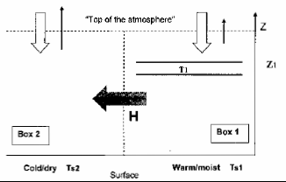
Figure 1 “Two-box model” of the Tropics. The warm/moist region (Box 1) has an absorbing layer at height $Z_{1}$of temperature $T_{1}$. The cold/dry region (Box 2) is assumed transparent to terrestrial radiation. The vertical arrows represent the energy exchange at the top-of-the atmosphere (solar in white, terrestrial in black). The gray horizontal arrow indicates the energy export from the warm/moist regions towards the cold/dry regions accomplished by the Atmosphere.

Cold/dry Ts2

(a) Denoting the surface temperature in Box 2 by $T_{s2}$and the temperature of the absorbing layer in Box 1 by $T_{1}$, write the energy budget for regions 1 and 2. You may assume that no energy is exchanged with the ocean surface.
[4 marks]

(b) Show that the sum of these two equations does not depend upon $H$and that it can be written as

${\text{aT}}_{1}^{4}+(1−a)T_{s2}^{4}=\frac{S}{σ(A_{1}+A_{2})}$ (1)

where $a≡{A_{1}}/(A_{1}+A_{2})$ represents the fraction of Tropics area occupied by the warm/moist regions.

NB: In case you have not answered a) you may recover this equation directly by thinking about the energy balance of the whole Tropics, rather than considering separately Box 1 and 2 and then summing their energy budget.
[3 marks ]

(c) Detailed calculations based on the equations obtained in a) show that an approximate solution exists for the mean tropical surface temperature - in which (assuming a simple parameterization of convection, as discussed in the lectures) is the surface temperature of the warm/moist regions- and is given by
(2)

where .

(i) Compute the value of, and give a physical interpretation of (you may use the fact that the area of the Tropics is half the area of the Earth, i.e. ).
[2 marks ]

(ii) By thinking about the equilibrium of each box when they do not exchange energy, check that the prediction (2) is consistent with what you expect in the case of no energy transport between moist and dry regions (i.e. when $H=0$).
[2 marks]

(d) The approximations made in deriving (2) are that (i) $a≈1/2$(ii) $H/S\text{<<}1$.

(i) Taking $a=1/2$and the energy export between warm/moist and cold/dry regions to be $H=5\text{PW}$ ($1\text{PW}={\text{10}}^{\text{15}}W$), check that the above approximations are satisfied. Compute, using (2), the tropical surface temperature expected in this case.
[2 marks]

(ii) By how much has $H$ to increase to reduce this estimate by 5K? Why is $T_{s}$ so insensitive to $H$?
[2 marks]

B3.

The ideal diode equation for the current density – voltage characteristic J(V) of a solar cell is given below:

$$J=J_{\text{SC}}−J_{0}\left(e^{{\text{eV}}/{\text{kT}}}−1\right)$$

(a) Define the terms J_{sc} and J₀ in this equation and explain how you would expect each of these to depend on voltage and on light intensity.
[4 marks]

(b) Sketch the curve of J(V) for an ideal solar cell (i) under illumination and (ii) in the dark.
[2 marks]

(c) State the main factors that determine the values of J_{sc} and J₀ in an ideal photovoltaic device. In a real solar cell, describe how J_{sc} and J₀ are changed, giving one mechanism that changes the value of J_{sc} with respect to its ideal value, and one mechanism that changes the value of J₀.
[4 marks]

(d) A solar cell has short circuit current density of 30 mA cm-2 and open circuit voltage of 0.6 V under one-sun illumination at room temperature. Use the ideal diode equation to estimate the open circuit voltage that is expected under illumination by sunlight concentrated by a factor of 100, stating any assumptions that you make.
[5 marks]

Boltzmann's constant k = 1.38 × 10-23 J K-1
Electronic charge q = 1.602 × 10-19 Coulomb

