Environmental Physics –
Mock Exam 2006 answers
Part A

A1. Not accurately. The greenhouse is maintained hot because the walls prevent mixing with surrounding (colder) air.

A2. The largest negative feedback is the Stefan-Boltzman feedback by which a warmer atmosphere emits more radiation to Space (the sensitivity is about $4{\text{Wm}}^{−2}$ more radiation emitted per K increase in atmospheric temperature). The largest positive feedback is the water vapour feedback by which a warmer atmosphere contains more water vapour, hence more greenhouse gas, which reduces the amount of radiation emitted to Space (the sensitivity is about $2{\text{Wm}}^{−2}$less radiation emitted per K increase in atmospheric temperature).

A3. The first factor represents the fraction of radiant power from the sun that is converted into heat in the converter. The heat (power) absorbed by the converter comes from the difference between the power absorbed by the converter from the sun and the power emitted by the converter. For full concentration of the solar power, the heat absorbed per unit area per unit time is given by

Q₁ = σT_{sun}⁴ - σT_{c}⁴

The fraction of solar power turned into heat is then Q₁/σT_{sun}⁴ which is the first factor. The second factor is the efficiency of work production by a Carnot engine operating between the converter temperature T_{c} and the ambient temperature T_{p} The net efficiency of solar power conversion into work is the product of the two factors. (Efficiency of Radiant power → heat * Efficiency of heat → work)

This efficiency is not achieved in practice because:
- Full concentration of sunlight cannot be achived practically
- Practical heat engines are less efficient than a Carnot engine (not perfectly reversible)
[Other plausible reasons also accepted.]

A4. Rate of energy production by woodland
= 7,000* 18 × 10⁶ J hectare⁻¹ year ^{–1}
= 7,000 * 1.8× 10⁷ * 1 × 10⁻⁴ J m⁻² year⁻¹
= 7* 1.8 / (365.25*24*3600) × 10⁶ J m⁻² s⁻²
= 4 × 10⁻⁷ * 1 × 10⁶ W m⁻²
= 0.4 W m⁻²

Efficiency = rate of energy production / incident solar power = 0.4/150 = 0.3 % to 1 s.f. Efficiency of a typical tree will be similar to that of woodland.

Non food energy requirements of a human in a developed country: estimate 2 kW [other reasonable estimates OK]. Area of forest needed: x m² * 0.4 W m⁻² = 2,000 W so x = 2000/0.4 = 5,000 m²

A5.
Note for examinations:
In the general introduction to the Environment, there were many graphs shown. Many were marked as being not examinable, and will not be therefore subject of questions. For those others, you need simply understand the main features and be able to interpret them as is discussed in this question.

It asks for bullet points – please do not write a time-consuming essay. Feel free to add in supplementary graphs if you think they are of significance. Many people think these questions are quite open-ended and therefore it’s difficult to assign an appropriate time to the answer. The marks allocated give you a clue as to how to do this. As a general rule, ensure you do not spend more than about 75% of the pro-rata number of minutes on questions like this. For example, this question assigns 6 marks out of a total of 100, in a 120 minute exam. It would be sensible to assign about 6 minutes to the answer, and foolish to assign more than 10. If six marks are allocated, mark quantisation suggests it would be foolish also to put down more than about 6 bullet points for each of the two questions.

Figure 1 shows the range of global average temperature change in degrees as a function of eventual CO2 stabilisation values in ppm
- The figure shows two curves increasing the temperature change significantly above present day temperatures. The upper curve, reaching up to + 6 degrees at 1000 ppm of CO2, is the temperature value reached once thermal equilibrium is reached. The lower curve shows the smaller temperature difference which will be reached by 2100. It is less than the other curve as equilibrium will be reached much later.
- Both curves have very large uncertainties – as much as ±2.5 K at the upper end, a reflection of uncertainties in the many models being used to assess climate change. However, these uncertainties (which are not defined in the figure) still result in a lowest expected temperature increase of 2-3 degrees at equilibrium and 1.5-2 by 2100.
- The climate and biosphere involves several important different time constants – in C)2 emission and absorption, in its effect on the climate
- The relationship between temperature and CO2 concentration is not linear, a reflection of large non-linear positive and negative feedbacks (eg cloud cover)
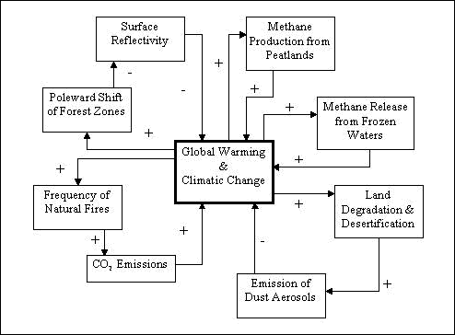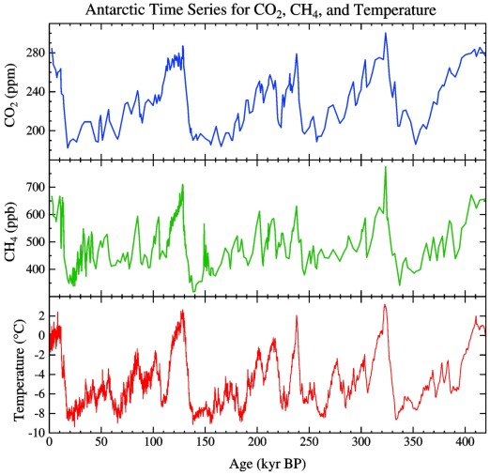
- The CO2 concentration has not gone beyond the range 280 – 380 ppm over at least 400,000 years according to the Vostock Ice core data or Antarctic ones (shown above), so the projected increases are very significant
- A 5 degree rise in temperature is roughly similar to that experienced between the last ice age and now.
In Figure 2, we see projected temperature change as a function of year from the present day up to 2100.
- There are a large number of models used in these projections and each has an inherent uncertainty indicated by the shaded spread in the curves’ envelope and quantified by the error bars to the right of the graph, each corresponding to a given model
- The trends suggest a likely temperature increase of 2 degrees by 2100, and while less than 1 degree appears to be excluded, as much as 5 degrees is probably not.
- Warming appears to be accelerating over the next 30 years, but all but one models appear to be slowing the rate of warming or even reaching an asymptotic value by 2100. The errors however are very significant.
- The large spread (2 degrees) in central values suggests there are many aspects still ill-understood in the models
- Warming comes from a range of inputs including most importantly CO2, (the biggest contributor), CH4, N2O and halocarbons, with tropospheric ozone and aerosols such as carbon from burning also positive effects. Stratospheric ozone is probably a negative effect.
- Scientific understanding of these issues is good, but there is still room for new findings which may be significant.
- Despite uncertainties, there is every reason to seek ways to reduce and mitigate against these effects.

- A6.
Gas concentration can be measured using the Beer Lambert law by measuring the absorption of at a specific wavelength – the so-called Differential Optical Absorption Spectroscopy technique. Like all absorption techniques DOAS makes use of the absorption of electromagnetic radiation by matter. Quantitatively the absorption of radiation is expressed by the Beer-Lambert law:

I(λ) = I₀(λ) exp (-x c σ(λ))
where I₀(λ) denotes the initial intensity of a light source
I(λ) is the intensity of the radiation after it has passed through a layer of thickness x,
where the species to be measured is present at the concentration c; σ(λ)denotes the absorption cross section at the wavelength λ which can be measured in the laboratory. Once σ(λ)is known, the trace gas concentration c can be calculated by:

c = D/ σ(λ)x where D, the optical depth = ln (I₀(λ) / I(λ) )

This neglects:
Extinction due to Rayleigh scattering
Extinction due to Mie scattering
Absorption by other molecules present in the atmosphere.

Errors include those associated with statistical shortcomings: the photon limit will not allow measurements over very large distances at whch point there is insufficient photon flux. Generally, the ratio of concentrations will be measurement more accurately. This requires a broad-band approach with well-understood wavelength dependent efficiencies.

b) This curve shows that the SO2 levels in Canada have decreased from over 12 ppb to around 5-6 ppb. The reduction in the 70’s coincides with the increasing awareness of the effect of ‘acid rain’ on natural environments.

Overall, emissions of sulphur dioxide in Europe and in this plot, in Canada, are estimated to have fallen by 25-30% between 1980 and 1990, and by 40% by the year 2000. Further falls in sulphur dioxide emissions are expected over the next decade.

(In June 1994, a number of European countries signed the Second Protocol for sulphur. Most of the western European countries agreed to reduce sulphur emissions by between 70 and 80% by the year 2000 (against 1980 levels) whilst eastern European countries generally have a lower target of between 40 and 50% (against 1980 levels).) I would not expect you to memorise this law stuff, but please note that SO2 provides a useful framework in which you can legislate against and help bring down the effects of Greenhouse gases.
Physics contributes through measuring, modeling and monitoring

Part B

B1.

Note: this sort of question usually follows the same sort of outline: there is an assessment of a source of energy in the context of a societal needs (in this case China’s huge population and their entirely reasonable desire to raise living standards. If there is information missing (in this case there isn’t but I was tempted not to give you the size of a nuclear power station) then just make your best estimate and state your assumptions clearly.

a) The annual power needs of China clearly are the population x the kWh/year/capita. You must be careful to distinguish between energy needs and electricity needs. In this question it’s reasonably ambiguous. 1.2386 x 10⁹ x (16349-871) = 1.92 x 10¹³ kWh/year is the increase δE_{china} necessary.

1kWh = 1000J x 3600 seconds = 3.6 x 10⁶J. So δE_{china} is equivalent to 6.90 x 10¹⁹ J

1 GW power station running for one year (=3.1536 x 10⁷ seconds) makes 3.15 x 10¹⁵ J

So China would need 2190 new nuclear power stations to make this energy ie 2190 GW installed base.

b) There are 350GW of nuclear power using 68000 metric tonnes p.a. The new build of part a) would use 2190/350 x 68000 metric tonnes p.a. = 4.25 x 10⁵ tonnes p.a. If there are 3.5 x 10⁶
tonnes available this equates to 8 years.

c) 400m terajoules = 400,000m Gjoules = 400 EJ which over a year equates to 12683 1GW power stations.

d) 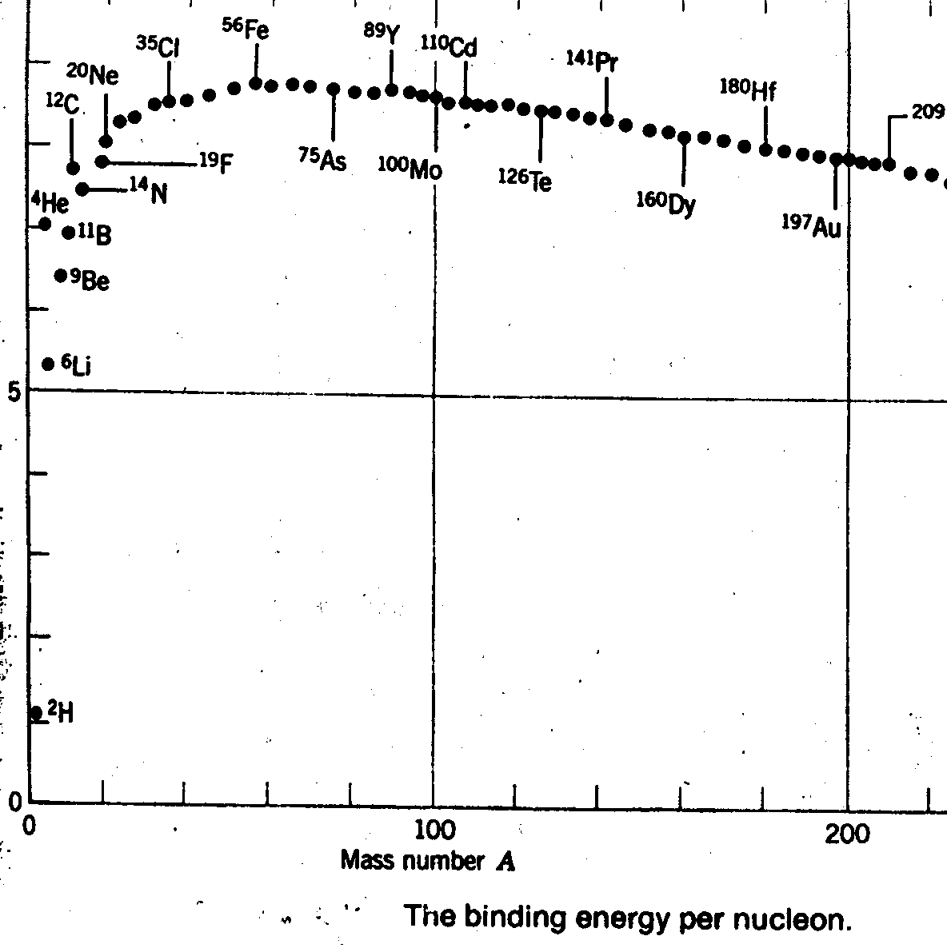
Fission breaks heavier nuclei into smaller ones, liberating of order 1MEV per nucleon
Fusion allows smaller nuclei to create larger ones, liberating of order 2-5 MEV per nucleon

B2.
a) Box1: $A_{1}{σT}_{1}^{4}=\frac{A_{1}}{A_{1}+A_{2}}S−H$ Box 2: $A_{2}{σT}_{s2}^{4}=\frac{A_{2}}{A_{1}+A_{2}}S+H$
b) The sum is $A_{1}{σT}_{1}^{4}+A_{2}{σT}_{s2}^{4}=S$ (this is simply the energy budget of the whole Tropics). Dividing by $σ(A_{1}+A_{2})$ and using the definition of $a$readily yields (1).

c(i) $T_{E}={\left(\frac{S}{σ(A_{1}+A_{2})}\right)}^{1/4}≈\text{267}K$ is the temperature required for a Stefan-Boltzman radiator to balance the solar energy input in the Tropics. This emission temperature is larger than the one discussed during the lectures ($T_{E}≈\text{255}K$). The reason is that here we focus on the Tropics for which the solar insolation is larger than that for the globe.

c(ii) When $H=0$, (2) predicts $T_{s}=T_{E}+{aΓZ}_{1}$. This is readily understood as the weighted sum of the warm/moist region temperature $T_{s1}=T_{E}+{ΓZ}_{1}$and that of the cold/dry region $T_{s2}=T_{E}$ when each region is in equilibrium.

d(i) Numerically, $S≈\text{75}\text{PW}$so $H/S≈5/{\text{75}}\text{<<}1$. We can safely use (2) to compute $T_{s}≈\text{267}+\frac{1}{2}6\text{.}5×1−\frac{3}{\text{32}×0\text{.}\text{25}}{\left(\frac{5}{\text{75}}\right)}^{2}\text{267}≈\text{300}K$

d(ii) As the figure below shows, one would have to increase $H$by a factor 3 to make $T_{s}≈\text{295}K$. The reason for this small sensitivity is that by exchanging energy from Box 1 to Box 2 we decrease $T_{s1}$but we also increase $T_{s2}$. At fixed $a$there is thus a compensation between these effects leading to small changes in $T_{s}={\text{aT}}_{s1}+(1−a)T_{s2}$ . The cancellation is not perfect though and this reflects the non linearity in Stefan-Boltzman law.

Full (continuous) and approximate (dashed, i.e. eq, (2)) solution of the two-box model for $T_{s}$ when $a=1/2$. This figure was produced with the Matlab code TwoBoxModel.m available on the course website.

B3.

(a) J_{sc} is short circuit current density. This is the current density extracted from the solar cell when the terminals are shorted out and the device is illuminated. It should increase with light intensity in rough proportion to intensity, and should not depend on voltage.

J₀ is the coefficient of the dark current, sometimes called the dark or diode saturation current density. The current passed through the device when a voltage is applied is proportional to J₀. To a first approximation, J₀ does not depend on light intensity or voltage. The voltage dependence of the dark current is expressed by the term in brackets.

(b)
(c) In an ideal solar cell all photons incident from the sun with E > E_{g} are absorbed and excited charges are lost only by recombination with the emission of light (to give an emission spectrum characteristic of the temperature of the solar cell). Then J_{sc} comes from integrating the incident spectrum over photon energies from the band gap E_{g} to infinity. So J_{sc} depends upon the band gap and the intensity of the spectrum (concentration factor). It would also depend upon the shape of the spectrum if a spectrum other than the solar was used. In the ideal cell J₀ comes from integrating the emitted spectrum of the solar cell over photon energies from E_{g} to infinity. It depends upon the band gap and the ambient temperature but should not depend on the solar spectrum or intensity.

In a real solar cell, other loss mechanisms are introduced. J_{sc} would be reduced relative to the ideal case due to mechanisms by which light is not absorbed or charges are lost before reaching contacts. Examples: reflection of light, incomplete absorption of light; short diffusion length of charges. J₀ would tend to be increased relative to its ideal value by additional pathways for charge relaxation in the dark. Example: non-radiative recombination

(d) Open circuit voltage V_{oc} is the voltage V when J = 0 so J_{sc} = J₀ (exp(eV_{oc}/kT)-1). Assume room temperature (kT = 0.025 eV)

30 = J0 (exp(0.6/0.025)-1)
J0 = 30 / 2.6 × 10¹⁰ = 1.13 × 10⁻⁹ mA cm⁻²

Light concentrated by factor 100. Assume J_{sc} increase by factor 100, i.e. J_{sc} = 3000 mA cm⁻²
V_{oc} = kT/e ln (J_{sc}/J₀+1) Therefore we expect a V_{oc} at 100 times solar light intensity of V_{oc} = 0.025 * ln (3000/1.13 × 10⁻⁹) = 0.71 V [other routes to this answer are acceptable]

