Problem Sheet 1 Environmental Physics
Note: in the exams, you would have access to supplementary graphs. In the case of these questions, all necessary material is posted on the course website.

- Hypothesise the discovery of a new North Sea Oil field Calculate how far back (in years)
the peak of global oil would be set. Assume Gaussian production curve.

- Assume the atmosphere acts as a perfect gas and the average temperature is the only
factor of importance in determining minimum central pressure of hurricanes. If the global average temperature rises by 3 degrees K, estimate the increase in the proportion of category 5 compared to category 4 and 3 hurricanes. List briefly reasons why this analysis unlikely to be accurate. You may wish to use the following simulation distributions.
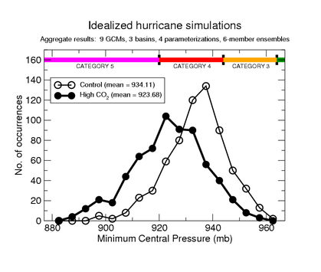
- Assume the Earth’s human population increases at 1.2% a year from its present 6.5bn and
reaches 15bn people (instead of the maximum 12bn projected by the UN). How many years will that take? Assume all people reach an average annual electricity consumption of 10,000 kW/h per person per year. Estimate how much CO2 would be emitted if the energy mix over this period continued in the same proportions as it is now. Estimate how much UO2 would be needed to provide this energy.

- The world consumes some 80m barrels of oil equivalent/day. Energy needs are expected
to go from the present 12.8TW (of which hydrocarbons make up about 5.6TW) to 20-30TW by 2050. To match the two different growths in power required, calculate the necessary percentage increases if only hydrocarbons were available.

ENVIRONMENTAL PHYSICS
Half Unit - Two hours.
The paper consists of two sections: A & B.
Section A will contain six short compulsory questions. (20 marks total)
Section B will contain four larger questions (2 out of 4 must be solved) (20 marks total)

Candidates are required to:
Answer ALL parts of Section A and some of B

